**SMART SCHEDULER**

**A PROJECT REPORT**

*Submitted by*

**GARALA MERI K. (110130107031)**

**PARMAR MIRAL M. (110130107065)**

*In fulfilment for the award of the degree*

*Of*

**BACHELOR OF ENGINEERING**

*In*

COMPUTER ENGINEERING



**Government Engineering College sector-28, Gandhinagar**

**Gujarat Technological University, Ahmedabad**

May, 2015

**Government Engineering College, Gandhinagar**

COMPUTER ENGINEERING

2015

**CERTIFICATE**

Date:

This is to certify that the Project entitled “**SMART SCHEDULER**” has been carried out by "GARALA MERI M." under my guidance in fulfilment of the degree of Bachelor of Engineering in COMPUTER ENGINEERING (8th Semester) of Gujarat Technological University, Ahmadabad during the academic year 2014-15.

|  |  |
| --- | --- |
| INTERNAL PROJECT GUIDE | HEAD OF DEPARTMENT |
| Prof. Namrata Shroff | Prof. M.B.Chaudhari |

**EXTERNAL PROJECT GUIDE**

**Mr. Kailash Prajapati**

**Government Engineering College, Gandhinagar**

COMPUTER ENGINEERING

2015

**CERTIFICATE**

Date:

This is to certify that the Project entitled “**SMART SCHEDULER**” has been carried out by "PARMAR MIRAL M." under my guidance in fulfilment of the degree of Bachelor of Engineering in COMPUTER ENGINEERING (8th Semester) of Gujarat Technological University, Ahmadabad during the academic year 2014-15.

|  |  |
| --- | --- |
| INTERNAL PROJECT GUIDE | HEAD OF DEPARTMENT |
| Prof. Namrata Shroff | Prof. M.B.Chaudhari |

**EXTERNAL PROJECT GUIDE**

**Mr. Kailash Prajapati**

**Patent Search and Analysis Report (PSAR) Reports**

**Submitted as a part of the**

**PROJECT REPORT**

***“Smart Scheduler”***

***Submitted by***

***GARALA MERI M. (110130107031)***

***In fulfillment for the award of the degree of***

**BACHELOR OF ENGINEERING**

**In**

*COMPUTER ENGINEERING*

**Government Engineering College sector-28, Gandhinagar**



**Gujarat Technological University**

**Ahmedabad**

**April, 2015**



**Government Engineering College sector-28, Gandhinagar**

Near GEB cross road, Sector-28, Gandhinagar – 382028, Gujarat

DECLARATION

We hereby declare that the PSAR Reports, submitted along with the Project Report for the project entitled ***“Smart Scheduler”*** submitted in fulfillment for the degree of **Bachelor of Engineering** in ***Computer Engineering***  to Gujarat Technological University**,** Ahmedabad**,** is a bonafide record of the project work carried out at **GECG-28** under the supervision *of* **Prof. Namrata Shroff** and that no part of any of these PSAR reports has been directly copied from any student’s reports or taken from any other source, without providing due reference.

Name of Students Sign

1. Garala Meri K.

2. Parmar Miral M.



**Government Engineering College sector-28, Gandhinagar**

Near GEB cross road, Sector-28, Gandhinagar – 382028, Gujarat

CERTIFICATE

This is to certify that the PSAR reports, submitted along with the project entitled **“Smart Scheduler”** has been carried out by **Garala Meri M.** under my guidance in fulfillment for the degree of: **Bachelor of Engineering** in **Computer Engineering 8th Semester** of Gujarat Technological University, Ahmadabad during the academic year 2014-15. These students have successfully completed PSAR activity under my guidance.

|  |  |
| --- | --- |
| PROJECT GUIDE | HEAD OF DEPARTMENT |
| Prof. Namrata Shroff | Prof. M.B.Chaudhari |



**Government Engineering College sector-28, Gandhinagar**

Near GEB cross road, Sector-28, Gandhinagar – 382028, Gujarat

CERTIFICATE

This is to certify that the PSAR reports, submitted along with the project entitled **“Smart Scheduler”** has been carried out by **Parmar Miral M.** under my guidance in fulfillment for the degree of: **Bachelor of Engineering** in **Computer Engineering 8th Semester** of Gujarat Technological University, Ahmadabad during the academic year 2014-15. These students have successfully completed PSAR activity under my guidance.

|  |  |
| --- | --- |
| PROJECT GUIDE | HEAD OF DEPARTMENT |
| Prof. Viral Borisagar | Prof. M.B.Chaudhari |

**TABLE OF CONTENT**

**Content Page No.**

**Acknowledgement 13**

**Abstract 14**

**List of Figures 11**

**1. Introduction ………….………………………………………………....…15**

1.1 Defination...........................................................................................................................15

1.2 Purpose………………………….………..…………………..………………………......15

1.3 Scope……………….…………………..………………………..………………….........15

1.4 Module Design…………………………………………………………………………...16

1.5literature review/pas (prior art search)……………………………………………………16

1.5.1 First Patent Research Work:-..................................................................................17

1.5.2 Second Patent Research Work…………………………………………………...18

1.5.3 Third Patent Research Work……………………………………………………..19

1.5.4 Fourth Patent Research Work…………………………………………………….20

1.5.5 Fifth Patent Research Work……………………………………………………...21

1.6 functional and nonfunctional requirements……………………………………………...21

1.7 technology used……………………………………………………………………………………………………………22

1.7.1 Software and Hardware Requirements…………………………………………...22

**2. Design: Analysis, Design methodology and Implementation strategy....24**

2.1workflow explanation……………………………………………………………………24

2.2 project planning and scheduling ………………………………………………………...26

2.2 1 project plan……………………………………………………………………….30

2.2.2 Project Scheduling……………………………………………………………… 30

2.2.3 Risk Management………………………………………………………………...24

2.3 System Analysis………………………………………………………………………….31

2.3.1 Overview…………………………………………………………………………31

2.3.2 Description of Present System…………………………………………………...31

2.3.3 Limitation of Present System…………………………………………………….32

2.3.4 Proposed System…………………………………………………………………32

2.4 System Diagrams…………………………………………………………………………33

2.4.1 Data Flow Diagrams……………………………………………………………...33

2.4.1.1 DFD level 0…………………………………………………………………….34

2.4.1.2 DFD level 1…………………………………………………………………….34

2.4.1.3 DFD level 2…………………………………………………………………….35

2.4.2 Use Case Diagrams……………………………………………………………....35

2.4.2.1 Use Case diagram for Student Description…………………………………….36

2.4.2.2 Use Case diagram for Student Profile Update………………………………….37

2.4.3 Activity Diagrams………………………………………………………………..38

2.4.3.1 Activity Diagram for student login…………………………………………….38

2.4.3.2 Activity Diagram for Student Profile Update…………………………………..39

2.4.3.3 Activity Diagram for Showing Time-table…………………………………….40

2.4.4 Sequence Diagrams……………………………………...……………………….41

2.4.4.1 Sequence Diagram for Student login…………...……………………………...41

2.4.5 Flow Charts………………………………………………………….42

2.4.5.1 Flow Chart for time-table……………………………………………………..42

2.4.6 Data Dictionary…………………………………………………………………..38

3. **Implementation………………………...………………………………....47**

3.1 Actual Implementation…………………………………………………………………...48

3.2 Testing…………………………………………………………………………………....57

3.2.1 What is Software testing?..........................................................................................57

3.2.2 Basics of Software testing………………………………………………………….57

3.2.3 Types of Testing……………………………………………………………………58

**4. Conclusion……………………………………………………………..…..60**

4.1 Future Work flow………………………………………………………………………...60

4.2 Scope of future work……………………………………………………………………..60

4.2.1 Features that can be added in future……………………………………………......60

4.3 Conclusion………………………………………………………………………………..61

4.4 bibliography and references……………………………………………………………...61

**LIST OF FIGURES**

|  |  |  |
| --- | --- | --- |
| **Figure No.** | **Figure Name** | **Page No.** |
| Figure 2.1 | Observation Matrix | **24** |
| Figure 2.2 | Ideation Canvas | **25** |
| Figure 2.3 | Product Development Canvas | **26** |
| Figure 2.4 | Project Development Life Cycle | **27** |
| Figure 2.5 | Software Release life cycle | **29** |
| Figure 2.6 | DFD level 0 | **33** |
| Figure 2.7 | DFD level 1 | **34** |
| Figure 2.8 | DFD level 2 | **35** |
| Figure 2.9 | Use case diagram for student | **36** |
| Figure 2.10 | Use case for Student login | **37** |
| Figure 2.11 | Activity diagram for student login | **38** |
| Figure 2.12 | Activity diagram for profile update | **39** |
| Figure 2.13 | Activity diagram for showing time-table | **40** |
| Figure 2.14 | Sequence diagram for student login | **41** |
| Figure 2.15 | Flow chart for showing time-table | **42** |
| Figure 3.1 | Login view | **47** |
| Figure 3.2 | Options view | **48** |
| Figure 3.3 | Select syllabus option | **49** |
| Figure 3.4 | Result view | **50** |
| Figure 3.5 | Profile update view | **51** |
| Figure 3.6 | Update mobile number | **52** |
| Figure 3.7 | Show alert box | **53** |
| Figure 3.8 | Notice view | **54** |
| Figure 3.9 | Show notice | **55** |
| Figure 3.10 | Placement details | **56** |

**Acknowledgement**

First of all with profound pleasure and deep gratitude we thank Prof. NAMRATA SHROFF and GECG administration for giving us good opportunity to explore this project.

We are very much thankful to Mr. KAILASH PRAJAPATI for his valuable guidance and useful suggestions and discussion during the span of this project. We are also thankful for their suggestions for literature material and moral support during this period.

H.O.D. of Computer and IT Department, Prof. M.B. CHAUDHARI, and the whole staff of Computer and IT Department of Government Engineering College, Sector-28, Gandhinagar.

ABSTRACT

SMART SCHEDULER

It is a mobile application and this application is used to store and manage data of every information related to a college. This application is made for college students. It provides many facilities like class time-table, internal exam schedule, syllabus, student’s personal details, notice, placement details, upcoming events and activities. This application is designed for college students who want to have their entire college life under control. Student can set reminder for extra lecture class, assignments and also reminds you of exams. They can get to know the upcoming events like seminar, events, placement schedule, general task etc. Smart student scheduler is a smart application which keeps college student life organized in better way and predictive. The main feature of this app is its timetable that shows your schedule for any particular day or week. Students can get placement details like upcoming companies for placement. Additionally there are many other helpful features, for example cost expenditure of the day basis as well as monthly. Student can easily updates his/her personal details in college registration like mobile number and Email-ID. Using this application student can get all the information very easily without visiting college daily.

**1. INTRODUCTION**

This chapter discuss about definition, objective and technical review for project.

* 1. **DEFINITION**

Smart Scheduler mobile application is made for college students. This application provide many facilities like class time table, internal exam schedule, syllabus, student’s personal details, notice, placement details, cost expenditure, upcoming events and activities .

**1.2 PURPOSE**

The Goal of a Smart Scheduler application is to provide all the information to the student.It is a smart application which keeps college student life organized in better way and predictive by providing many facilities*.*

**1.3 SCOPE**

Smart Scheduler application provides each user to perform their task as per their role in the system, as follows:

1. **System Administrator:**

* Admin have access to all the database tables and backend code.
* It can insert, delete and update time-table, syllabus, notice and placement details.
* Admin can upload many documents. It can also remove documents from application if rules and standards are broken.
* Admin can access every module integrated in this project.

**2. Student**

* Student can access this application using simply login process.
* Student can update his/her personal details like password, Email-ID, mobile number.
* Student can watch or download documents from class it is subscribed to.
* Student can check for news updates or updates related to placement.
* Student can watch his/her timetable, internal exam Schedule, syllabus, notice, personal details and placement details.

**1.4 MODULE DESIGN**

In this Application following Modules are Present.

* **Student**
* Student first has to login to the system.
* Student can see Notice, Syllabus, Time-table, Result, Profile Update and placement details and Notes.
* Student can watch documents from notice.
* Student can update his/her personal details like mobile number, Email id and password.
* Student can add or remove their important notes into the notes section.
* Faculty:

Faculty give information regarding to submission, practical list, assignment list, and extra lecture arrangement details etc. provides to students easily.

* HR:

Placement related information provide to students through HR faculty easily and all detailed information students store in them notes.

* PRINCIPAL:

Principal give information like event organization, seminar arrangement, competition etc. to students very quickly.

**1.5** **LITERATURE REVIEW/PAS (PRIOR ART SEARCH)**

This is summary report for patents searched by me as a part ad prior art.

In this chapter fundamental aspects of patents are covered such as patent no, Title of Invention, Limitations of Prior Technology, and Objective of Invention.

This project also indicates at which level Patents searched by me are related to my project. Some opinions are also including in this chapter.

1.5.1 **First Patent Research Work:-**

|  |  |
| --- | --- |
| First Patent Research Work | |
| Patent No | US20070250370 A1 |
| Title of Invention | Scheduling application and distribution method |
| Limitation of Prior Technology | The present invention relates generally to the field of electronic scheduling and rescheduling and, more particularly, to a web or other electronic based calendar and scheduling and rescheduling application providing information and management through wireless messaging and other related communication methods. |
| Objective of Invention | A scheduling application providing information and management through SMS messaging and other related communication methods is proposed. The application can allow a user to create and modify a database of user contact and schedule information, and then utilize this information to produce a schedule for a select group of users. Information related to this schedule can then be communicated to the users through the stored contact information, and modifications and updates to the schedule can be made based on user response. |

1.1 First Patent Research Work

**1.5.2 Second Patent Research Work:-**

|  |  |
| --- | --- |
| Second Patent Research Work | |
| Patent No | US 20070184423 A1 |
| Title of Invention | Updating student records in student profiles |
| Limitation of Prior Technology | when a student enrolls in tutorial or supplemental educational programs, he or she completes a series of primarily paper-and-pencil diagnostic tests to identify subject-specific skill gaps. Once these tests are corrected and analyzed against a given curriculum of subject-specific learning objectives, a teacher or supervisor outlines a personalized program of instruction through which the student will master the subject. |
| Objective of Invention | This invention is a computer based system for the assessment, management and instruction of students, and for the delivery of work pages and other instructional materials in the form of electronic student workbooks. The computer based assessment of the student produces a student profile including skill gaps or learning objectives. |

* 1. Second Patent Research Work

**1.5.3 Third Patent Research Work:-**

|  |  |
| --- | --- |
| Third Patent Research Work | |
| Patent No | US 20140074740 A1 |
| Title of Invention | Systems and methods for providing career advice to college students |
| Limitation of Prior Technology | The present disclosure relates generally to methods and systems for providing career advice to college students and, in particular, to providing career advice to college students by facilitating career network connections. |
| Objective of Invention | Methods and systems for providing career advice to a college student are disclosed. In some embodiments, the method may include receiving one or more user vocational interests of the college student and generating a user interest vector based on the one or more user vocational interests. |

* 1. Second Patent Research Work

**1.5.4 Fourth Patent Research Work:-**

|  |  |
| --- | --- |
| Fourth Patent Research Work | |
| Patent No | US 20080138785 A1 |
| Title of Invention | Method And System for Evaluating Student Progess |
| Limitation of Prior Technology | The disclosed subject matter is directed to an electronic and computerized system, and method for evaluating the progress of students based on administrative, including academic, and socially observed data. |
| Objective of Invention | A method and system for evaluating the progress of a student. Initially, achievement data for the student, including classes of data comprising behavioral data, grade data, reading proficiency data, and standardized test score data, is processed to generate an individual achievement index score for each of the classes of data. |

1.4 Second Patent Research Work

**1.5.5 Fifth Patent Research Work:-**

|  |  |
| --- | --- |
| Fifth Patent Research Work | |
| Patent No | US 20110107232 A1 |
| Title of Invention | Directory and notification system for college students based on individual user profiles |
| Limitation of Prior Technology | This invention relates to online search and notification systems and, more particularly, to a searchable online directory of events, organizations, etc. and an electronic notification system that informs users of various events, activities, organizations and other matters of interest through various mediums (e.g., member page on system website, email, text messaging, RSS, calendar) based on individual user profiles. |
| Objective of Invention | An Internet (web based) system is adapted for enriching a user's college experience by helping the user discover and keep informed of events, activities, organizations (e.g., clubs), lectures, local businesses (i.e., merchant advertisements) and other matters that may be of particular interest to the user based on a “user interests profile” generated from personal data collected from the user. |

* 1. Second Patent Research Work

**1.6 FUNCTIONAL AND NONFUNCTIONAL REQUIREMENTS**

* **FUNCTIONAL REQUIREMENTS**
* Student can access application simply through login in IPhone mobile.
* Lectures can be attended either at the scheduled time or request view lecture at a later time.
* Faculties can upload assignments, announcements and can also upload other documents.
* Asynchronous communication in the form of e-mails or android notification app that enables communication to occur at “convenient times”.
* Student can store important notes into the application.
* This application provides day wise time-table.
* **NON-FUNCTIONAL REQUIREMENTS**
* Secure access of confidential data inside the college premises.
* Service availability during online.
* Better component design to get better performance at peak time.
* Flexible service based architecture will be highly desirable for future extension.
* It should be interactive, user friendly and also robust.
* Database must provide concurrent access.
* Database is to be Updated Based On Google API or third Party Responce Based on the Response.

**1.7 TECHNOLOGY USED**

This chapter discuss about software and hardware, functional and non functional requirements and also about risk management.

**1.7.1 Software and Hardware Requirements**

**Requirements for mobile devices:**

|  |  |
| --- | --- |
| Technical Specification | Requirements |
| Ios version | 7 |
| Processor | 1GHz Apple A4 |
| RAM | 512MB |
| GPS | YES |
| Internet connection | YES |

**Requirements for Machine:**

* Apple Mac

**Software Requirements:**

* MAC OS: 10.7
* XCode :4. 6.2
* iOS:6.1SDK
* iOS simulator:7.1
* Safari:3.10

**CHAPTER- 2 Design: Analysis, Design methodology and Implementation strategy**

System analysis is the process of gathering and interpreting facts, diagnosing problems and using the facts to improve the system. System specifies what system should do. A system is a set of components that interact to accomplish some purpose.

* Identifying the drawback of the existing system
* Identify the need for conversion
* Perform feasibility study
* Identify hardware, software and database requirements
* Create a system definition that forms the foundation for subsequent work.

**2.1 WORKFLOW EXPLANATION**

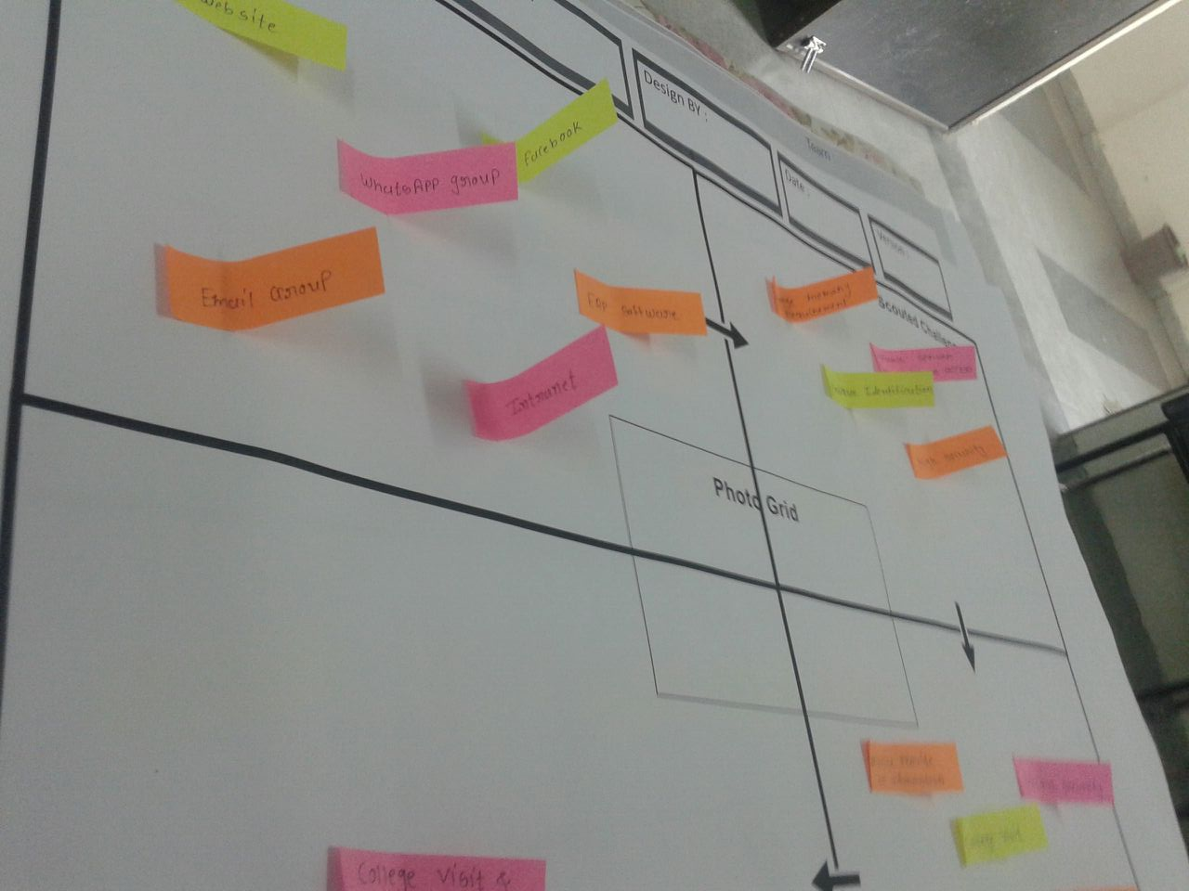

Figure. 2.1 Observation Matrix

The Observation Matrix made us notice what the current system was lacking. It helps us to find the lack in coordination between student and colleges. It help us to find the problem faced by student and the solution we can provide.

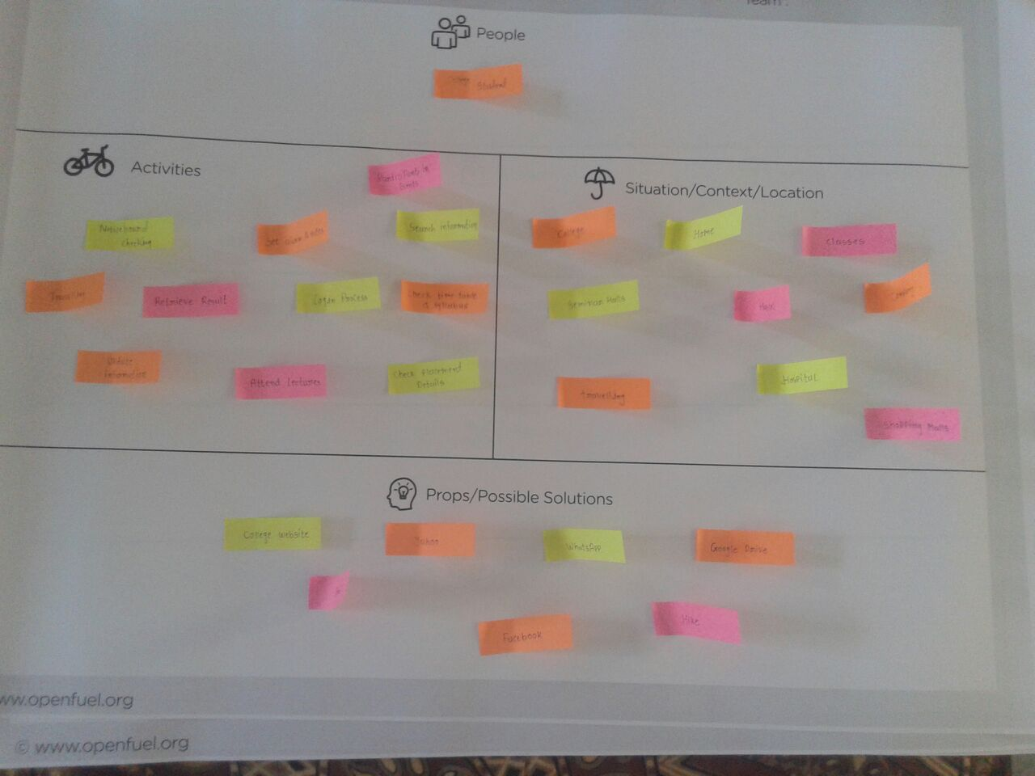

Figure. 2.2 Ideation Canvas

The Ideation Funnel Canvas made us think of the various End users who will be using the finished product. The various modules required by students and the possible solutions are available and we try to modify it according to the requirement.

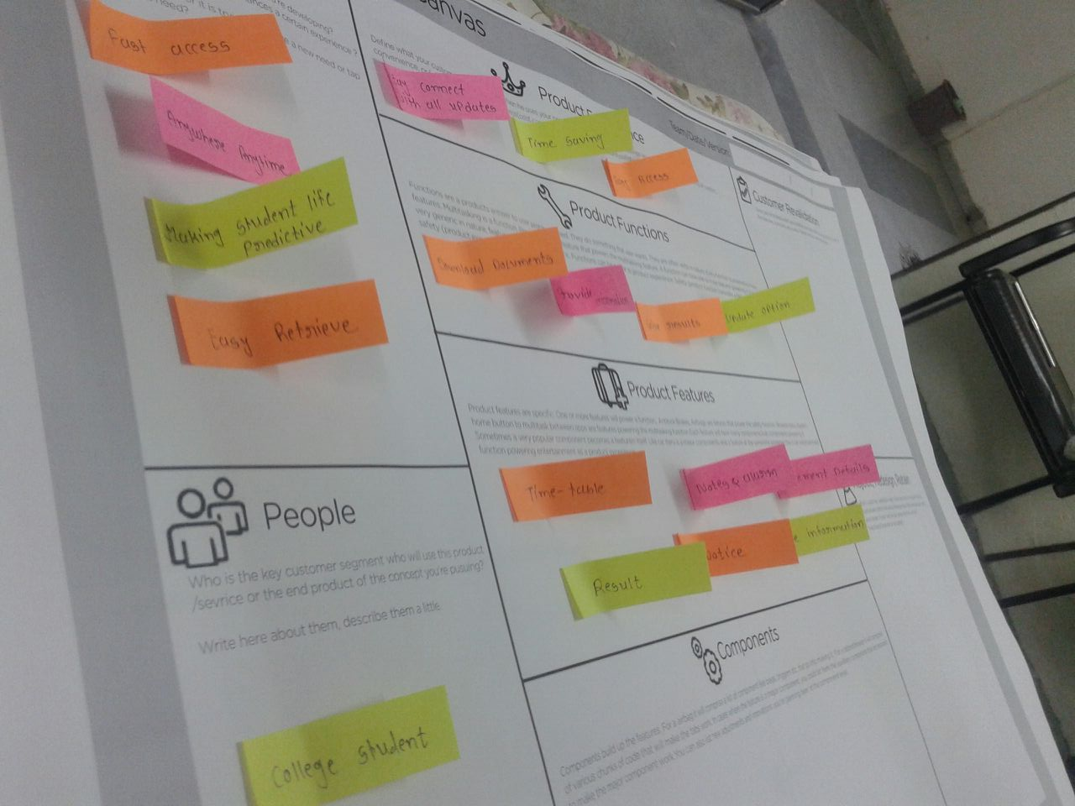

Figure. 2.3 Product Development Canvas

The sole purpose of the app was to provide all necessary information to the students. With the help of this app students can access very easily all the data. This app provides facilities like notice, time-table, syllabus, placement information, result and cost expenditure, etc.

**2.2 PROJECT PLANNING AND SCHEDULING**

Software project management is the art and science of planning and leading software projects. It is a sub-discipline of project management in which software projects are planned, implemented, monitored and controlled. The graphical representation of Software Project Management is shown in Figure.

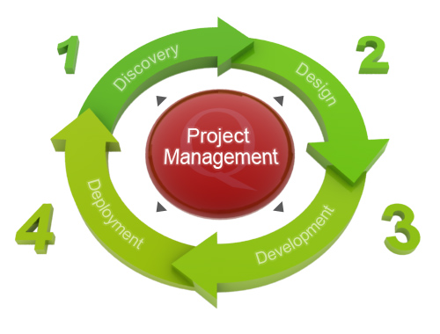

Figure 2.4: Project Development life cycle

In the 1970s and 1980s, the software industry grew very quickly, as computer companies quickly recognized the relatively low cost of software production compared to hardware production and circuitry. To manage new development efforts, companies applied the established project management methods, but project schedules slipped during test runs, especially when confusion occurred in the gray zone between the user specifications and the delivered software. To be able to avoid these problems, softwareproject management methods focused on matching user requirements to delivered products, in a method known now as the waterfall model.

As the industry has matured, analysis of software project management failures has shown that the following are the most common causes:

1. Unrealistic or unarticulated project goals
2. Inaccurate estimates of needed resources
3. Badly defined system requirements
4. Poor reporting of the project's status
5. Unmanaged risks
6. Poor communication among customers, developers, and users
7. Use of immature technology
8. Inability to handle the project's complexity
9. Sloppy development practices
10. Poor project management
11. Stakeholder politics
12. Commercial pressures

The first three items in the list above show the difficulties articulating the needs of the client in such a way that proper resources can deliver the proper Application goals. Specific software project management tools are useful and often necessary, but the true art in mobile Application Development is applying the correct method and then using tools to support the method. Without a method, tools are worthless. Since the 1960s, several proprietary software project management methods have been developed by software manufacturers for their own use, while computer consulting firms have also developed similar methods for their clients. Today software project management methods are still evolving, but the current trend leads away from the waterfall model to a more cyclic project delivery model that imitates a Software release life cycle.

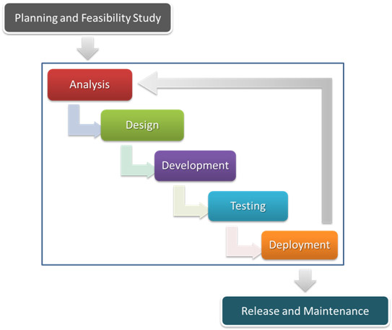

Figure 2.5: Software release life cycle

The risk factors as mentioned above which actually holds the potential of the failure of the project are well thought upon and some pro-active measures are taken and/or will be taken if necessary to justify the project requirements and the developer’s commitment towards the development of the whole system.

**2.2 1 Project Plan**

The fixation of the Application development approach might not be good enough for such a huge Application to get evolved from scratch. Some planning has to be undertaken before the commencement of the project so that future threats can be overcame by some solid planning and project management.

Time can be a matter of concern in this case. The evolution of such a humongous project is no doubt time as well as effort consuming. So the time management must be the foremost factor that needs to be taken under consideration before commencement of the project. The idea of time consumption by our project can be demonstrated by the descriptive graph below.

**2.2.2 Project Scheduling:**

Project scheduling is one of the main key aspects of any project. Any project must be scheduled before developing it.

When project developer works on scheduled project it is more advantageous for him/her to compare to unscheduled project. It gives us timeline for finishing the particular activity. Scheduling gives us idea about project length, its cost, its normal duration of completion and we can also find out the shortest way to complete the project with less overall cost of project.

**2.2.3 Risk Management:**

Risk management is the process of measuring or assessing risk and then developing strategies to manage the risk. In general, the strategies employed include transferring the risk to another party, avoiding the risk, reducing the negative effect of the risk, and accepting some or all of the consequences of a particular risk. Risk management in software project management begins with the business case for starting the project, which includes a cost-benefit analysis as well as a list of fallback options for project failure, called a contingency plan. There are certain steps carried by Risk Management:

**1. Risk Identification:**

**People risk:**

* Programmer done any progmming mistake like in coding, connection between UIElements and function.
* Properly not analysis on students requriments.

**Technical risk:**

* Connection of internet may be weak.
* Database connectivity may be not working quickly.

**2. Categories of risk:**

**Performance Risk:**

How much product satisfies needed requirements.

**Schedule Risk:**

Working flow of project is maintained step wise and finish at as per user requirements.

**2.3 SYSTEM ANALYSIS**

This chapter discuss about overview of system analysis, description and limitation of present system, module design and proposed system.

**2.3.1 Overview**

Smart Scheduler mobile Application is very useful to the college student.Using this application they can get all the information which is regularly update without visiting college or university. Smart Scheduler application can provide information to a particular student via email or message.

Smart Scheduler application provides many other facilities like cost expenditure, notes and alarm. Student can update his/her personal details. Smart student scheduler is a smart application which keeps college student life organized in better way and predictive.

**2.3.2 Description of Present System**

The present system provides many facilities which is to be Available in only One Screen Of Application.So no need to be for further work.for Ex. for Mail Suppose to be mail no need to explicit open the browser and than mail instead use default programs to do this Function.

**2.3.3 Limitations of Present System**

The Main aim of to Devlope this Application is to provide Information like result,syllabus,time-table,internal exam schedule,placement information and every updates into the college in Using One Screen Interface,

Web browser is also provide facilities for time-table,syllabus,upcoming events and activities,but not on hand or convenient way.or provide lots of data about it.but we need only necessary info or specific information.So,that can be possible with this application.But in this app. provide GUI that formatted in such away user can select any option in one panel.

For example, suppose 7thsem CE student need syllabus of ACT subject for this he has find information on internet and he get many option and then he find it’s particular needed information on it. This process is very time consuming and probably to not get right information at a time.

This application provide syllabus to students according to them branch and semester, so student can get easily information whatever they need in effortless time. Also help in reduce time-consuming to get information.

**2.3.4 Proposed System**

Looking at all the limitations and drawbacks of present system, a proposed system overcomes its limitations increasing efficiency of the Application. Following are aspects which are proposed by Smart Schedular

* The proposed Application involves usage of Database to store and manage data related to syallabus, time-table details etc.
* At time it proposed only minimum Module but this Application is used for regular getting information about college so it is possible to add different module in Future.

**2.4 SystemDiagrams**

This chapter describe the DFD, use case , activity , sequence and flowchart of project.

**2.4.1 Data Flow Diagrams**

**2.4.1.1 DFD level 0**

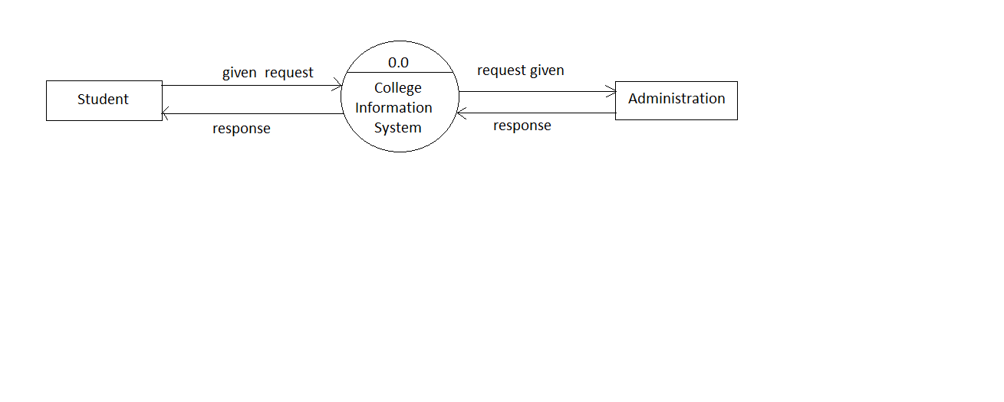

Figure 2.6: DFD level 0

**2.4.1.2 DFD level1**

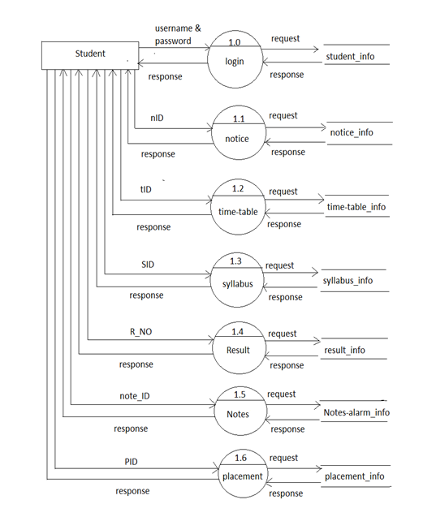

Figure 2.7 :DFD level 1

**2.4.1.3 DFD level 2**

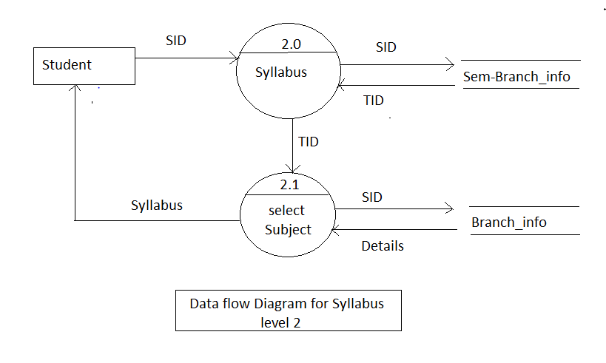

Figure 2.8: DFD level 2

**2.3.2 Use Case Diagrams**

**2.3.2.1 Use Case diagram for Student Description**

* A student has to login first to the system.
* A student can look up for updates like new notice, circulars and warnings if any.
* A student can watch documents and download tutorials and download important files related to educational surrounding.
* A student can view or update his/her profile if needed.
* A student can store his/her important details into the note section.

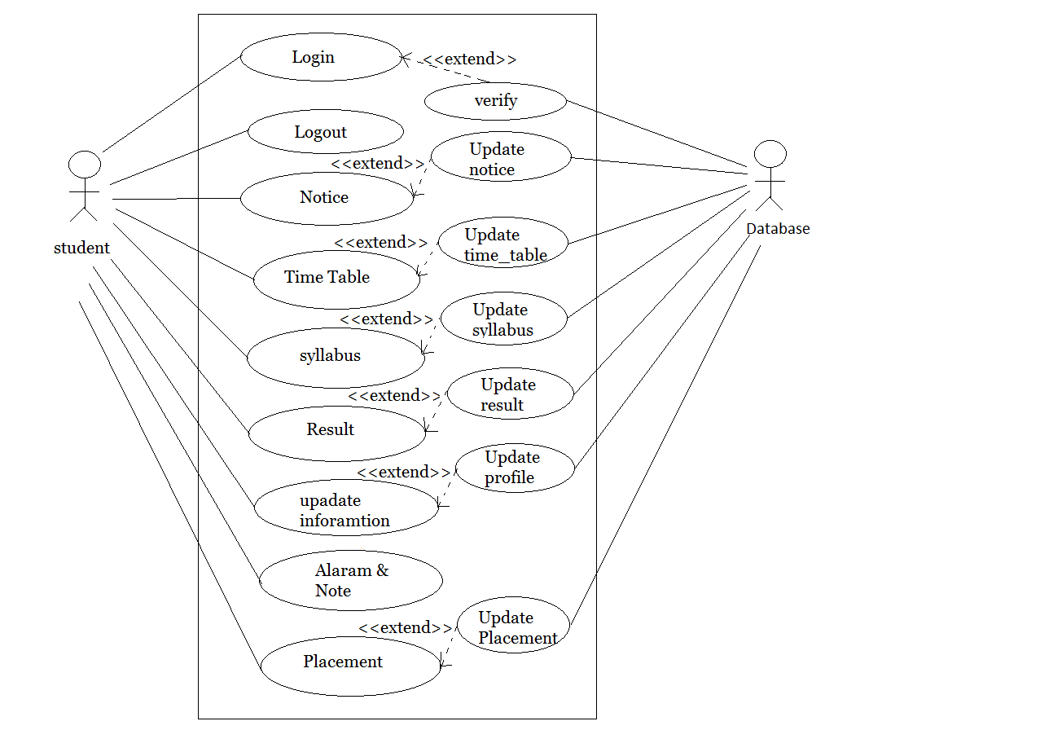

Figure 2.9 : Use case diagram for students

**2.3.2.2 Use case Diagram for Student Profile update**

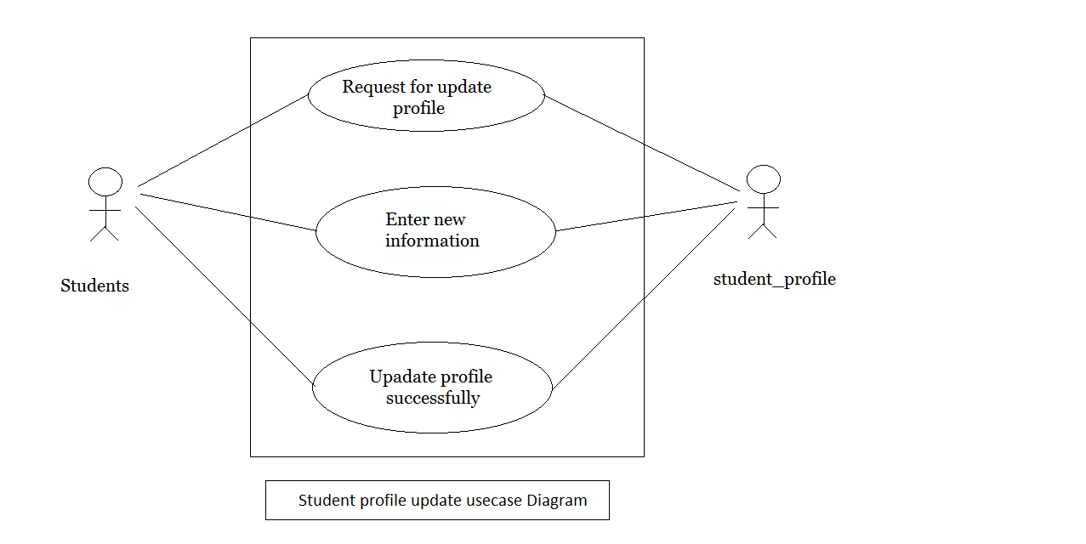

Figure 2.10: Use case diagram for students login

**2.4.3 Activity Diagrams**

**2.4.3.1** Activity Diagram for student login

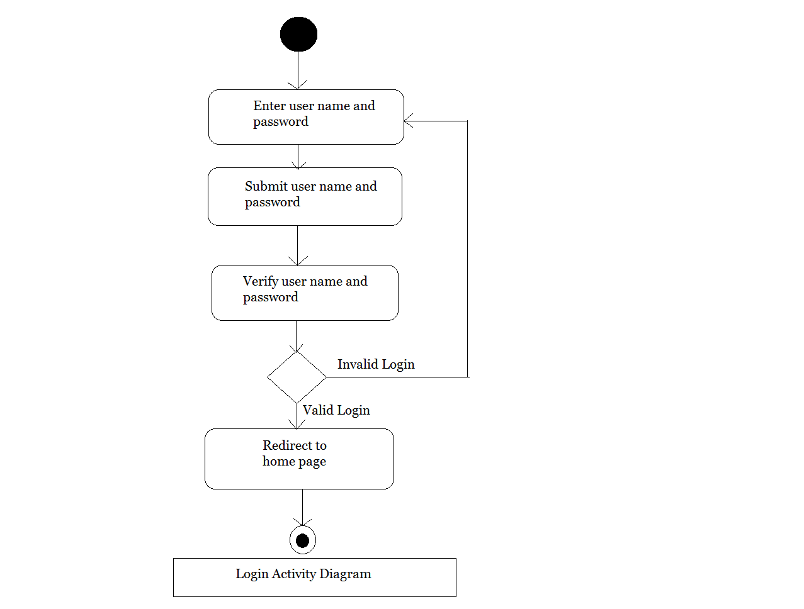

Figure 2.11:Activity diagram for students login

**2.4.3.2** **Activity Diagram for Student Profile Update**

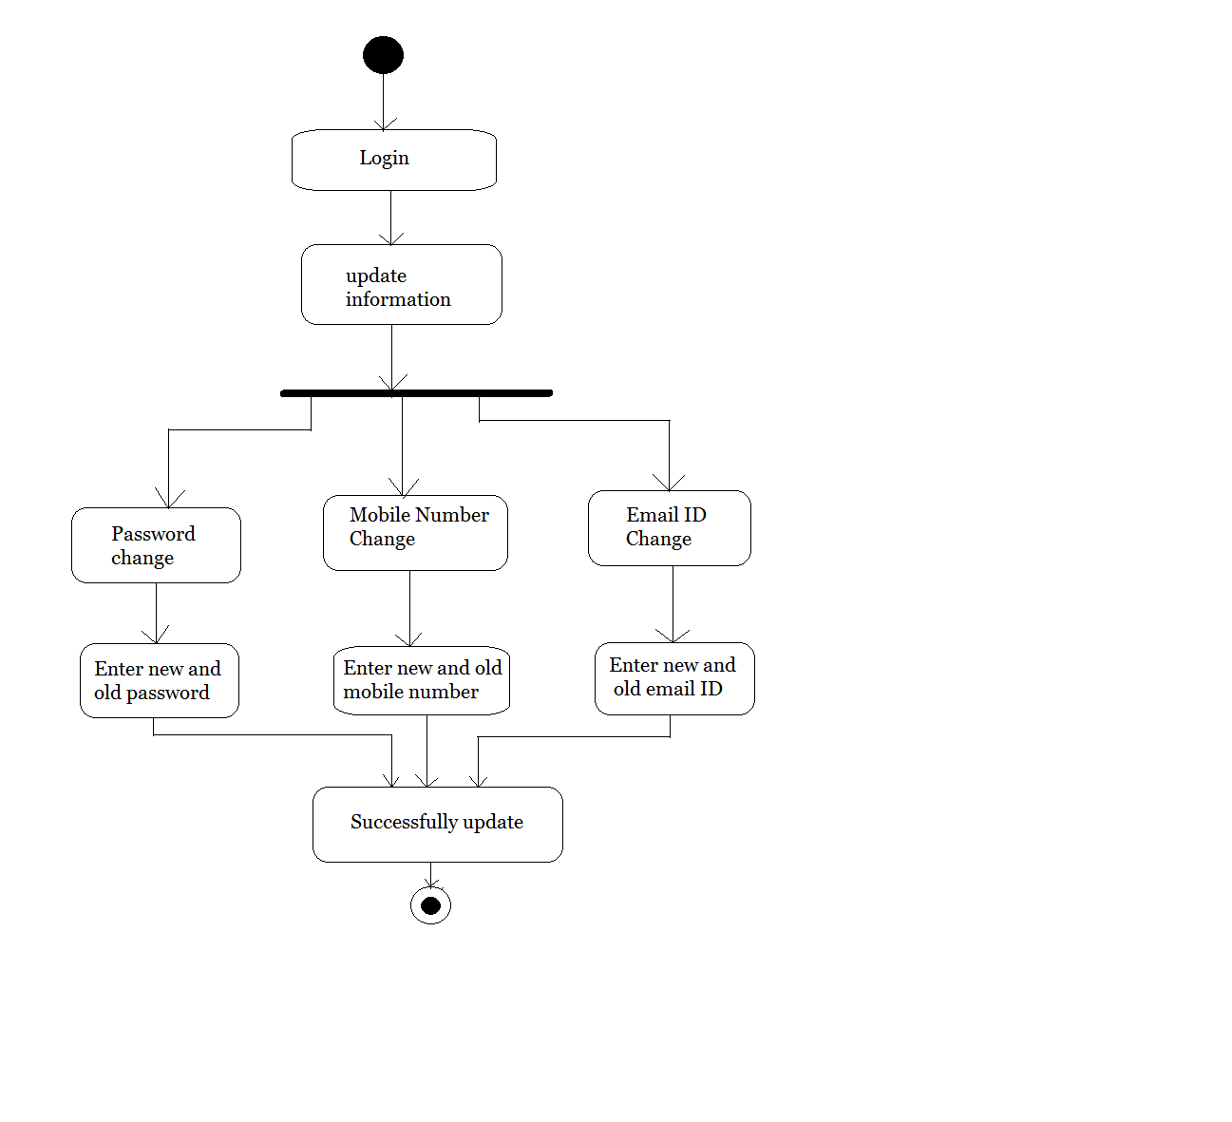

Figure 2.12 : activity diagram for students profile update

**2.4.3.3 Activity Diagram for Showing Time-table**

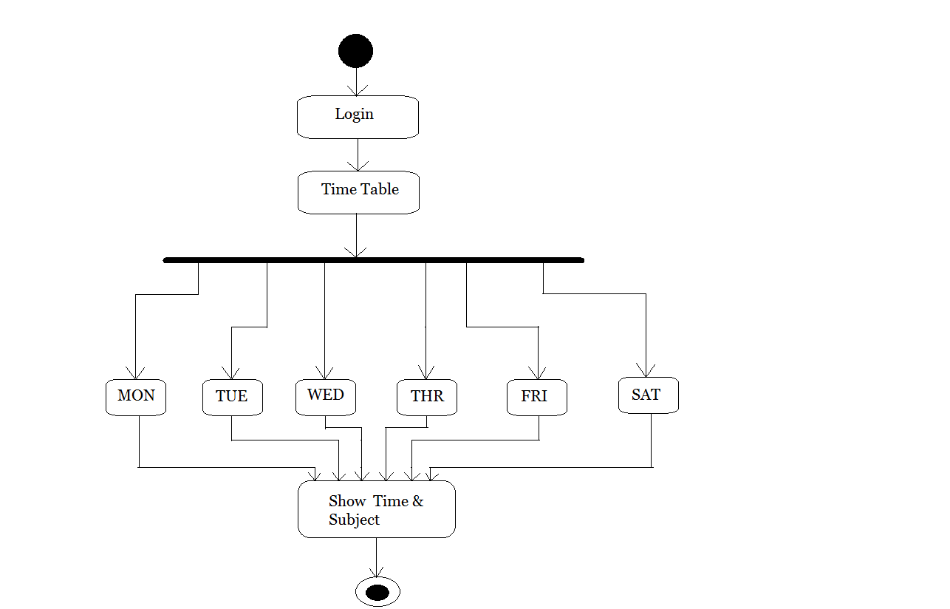

Figure 2.13:Activity diagram for showing time-table

**2.4.4 Sequence Diagrams**

**2.4.4.1 Sequence Diagram for Student login**

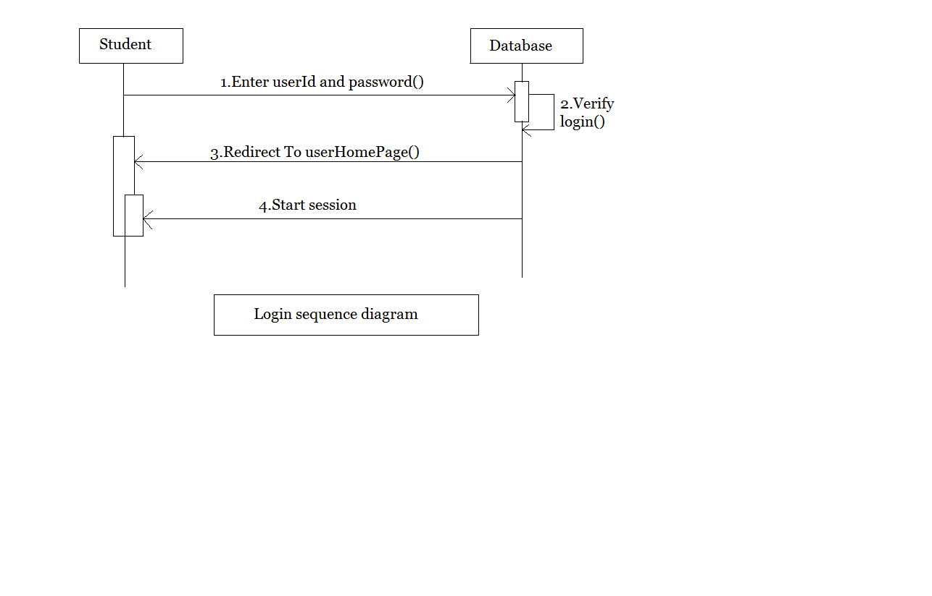

Figure 2.14:Sequence diagram for student login

**2.4.5 Flow Charts**

**2.4.5.1 Flow Chart for time-table**

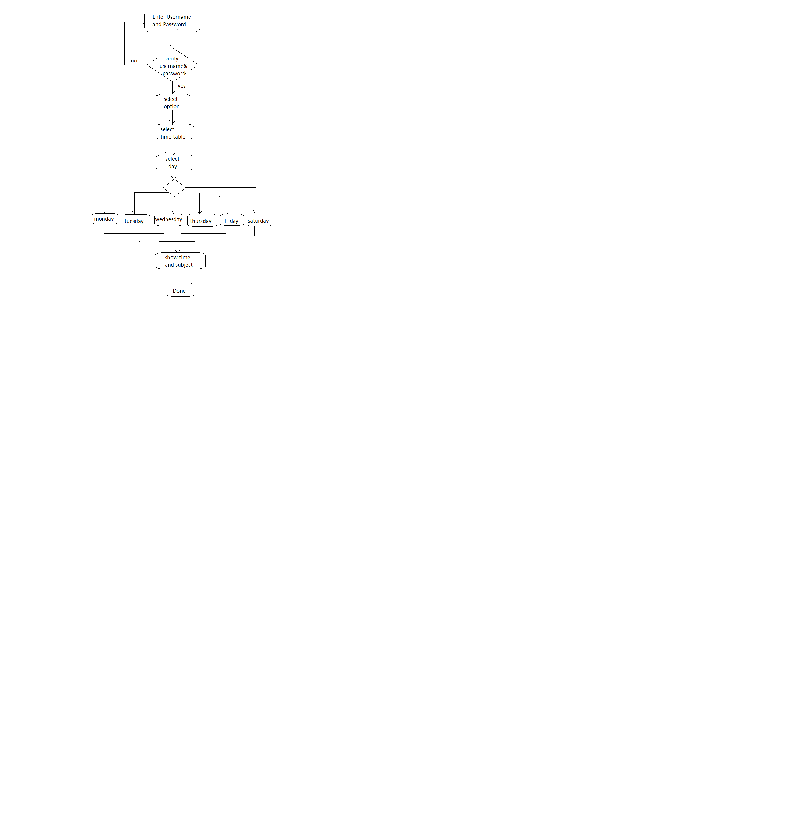Figure 2.15:Flow chart for showing time-table

|  |  |  |  |  |
| --- | --- | --- | --- | --- |
| Field Name | Data Type | Length | Key | Description |
| Rowed | Int | MAX | Primary Key | Serial number |
| Enno | Varchar | 12 | - | Students enrollment number use as user id for login |
| Name | Varchar | MAX | - | Students full name |
| semester | Varchar | 2 | - | Students current semester |
| branch | Varchar | MAX | - | Students branch name |
| mobile | Number | 10 | - | Students mobile number |
| emailid | Varchar | MAX | - | Students email id |
| password | Varchar | 15 | - | Students password for login |

**2.4.6 Data Dictionary**

profileinformation

2.5 profileinformation

branchID

|  |  |  |  |  |
| --- | --- | --- | --- | --- |
| Field Name | Data Type | Length | Key | Description |
| rowid | Int | MAX | Primary key | Serial Number |
| bname | Varchar | MAX | - | Branch name |
| Id | Varchar | MAX | - | Branch id |

2.6 branchID

notesinformation

|  |  |  |  |  |
| --- | --- | --- | --- | --- |
| Field Name | Data Type | Length | Key | Description |
| Rowed | Int | MAX | Primary key | Serial Number |
| Enno | Varchar | 12 | - | Students enrollment number |
| Title | Varchar | MAX | - | Notice title |
| Notes | Varchar | MAX | - | Notes description |
| date | Varchar | MAX | - | Show dates |

2.7 notesinformation

noticeinformation

|  |  |  |  |  |
| --- | --- | --- | --- | --- |
| Field Name | Data Type | Length | Key | Description |
| rowid | Int | MAX | Primary key | Serial Number |
| Noticeid | Varchar | MAX | - | Notice id |
| SBid | Varchar | MAX | - | semester branch id |
| noticetitle | Varchar | MAX | - | Show Notice title |
| noticedetails | Varchar | MAX | - | Notice description |
| date | Varchar | 15 | - | Show dates |

2.8 noticeinformation

subjectinformation

|  |  |  |  |  |
| --- | --- | --- | --- | --- |
| Field Name | Data Type | Length | Key | Description |
| rowid | Int | MAX | Primary key | Serial number |
| SUBid | Varchar | 10 | - | Subject id |
| SBid | Varchar | MAX | - | Semester branch id |
| subject | Varchar | MAX | - | Subject name |
| syllabus | Varchar | MAX | - | Syllabus discription |

2.9 subjectinformation

timetableinformation

|  |  |  |  |  |
| --- | --- | --- | --- | --- |
| Field Name | Data Type | Length | Key | Description |
| rowid | Int | MAX | Primary key | Serial number |
| Tid | Varchar | MAX | - | Timetable id |
| Dayid | Varchar | MAX | - | Day id |
| SUBid | Varchar | 10 | - | Subject id |
| time | Varchar | 15 | - | Describe time |

2.10 timetableinformation

holidayinformation

|  |  |  |  |  |
| --- | --- | --- | --- | --- |
| Field Name | Data Type | Length | Key | Description |
| Serial | Int | MAX | Primary key | Serial id |
| Holiday | Varchar | MAX | - | Holiday id |
| Date | Varchar | 15 | - | Describe date |
| Day | Varchar | MAX | - | Describe day |

2.11 holidayinformation

placementinformation

|  |  |  |  |  |
| --- | --- | --- | --- | --- |
| Field Name | Data Type | Length | Key | Description |
| Rowed | Int | MAX | Primary key | Serial number |
| SBid | Varchar | MAX | - | semester branch id |
| Notes | Varchar | MAX | - | Notes description |
| Placementitle | Varchar | MAX | - | Placement title |
| Date | Varchar | MAX | - | Describe date |

2.12 placementinformation

resultinformation

|  |  |  |  |  |
| --- | --- | --- | --- | --- |
| Field Name | Data Type | Length | Key | Description |
| rowid | Int | MAX | Primary key | Serial number |
| Enno | Varchar | 12 | - | Students enrollment number |
| SUBid | Varchar | 10 | - | Subject id |
| marks | Varchar | 3 | - | Describe marks |

2.13 resultinformation

**Chapter 3: Implementation**

**3.1 ACTUAL IMPLEMENTATION**

* **Login Form:**

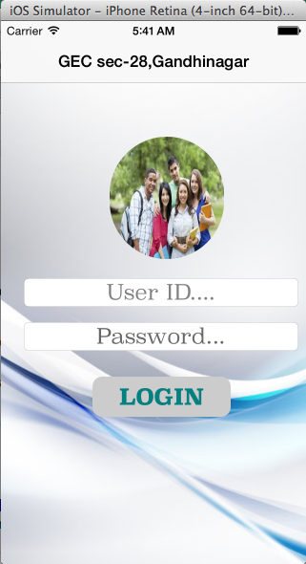

Figure 3.1:Login view

* Student login through enter username and password which is provided by college.
* **Option view-controller:**

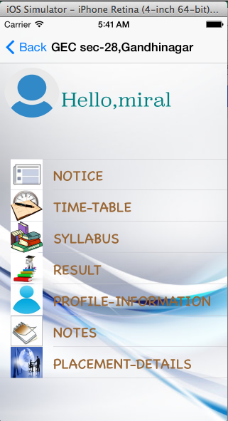

Figure 3.2: Options view

* Students can see different option
* Students select an option for showing its needed information.

* **Select syllabus option:**

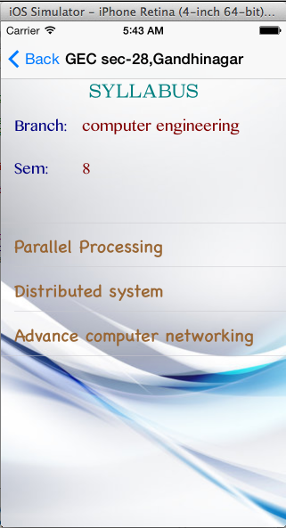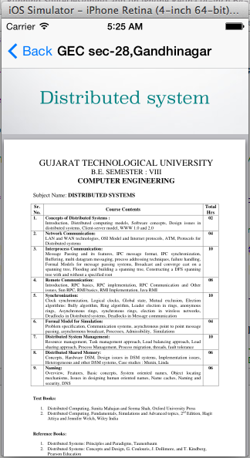

Figure 3.3: Select syllabus option

* Student can select syllabus option from option menu.
* Student shows his\her subject list according them semester and branch.
* From this list student choose a subject and show syllabus according to select subject as like show into the figure.
* **`Select result option:**

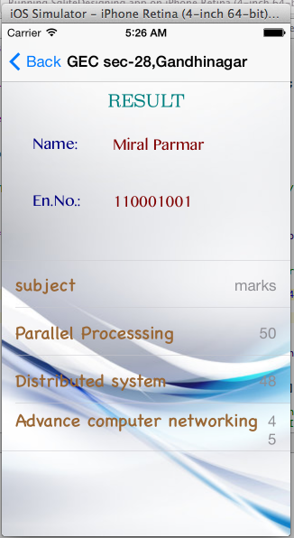

Figure 3.4: Result View

* Students can select result option from option menu.
* Students see their result of midterm exam or class-test.
* **Select profile update option:**

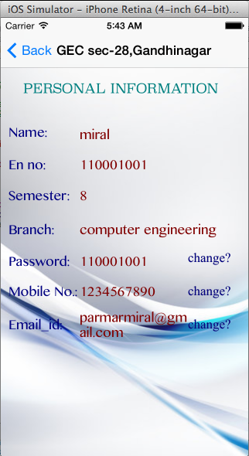

Figure 3.5: Profile update view

* Student select profile update option.
* Student see them profile information according college registration.
* Form this, student can change them mobile number, email-id and login password.
* Whatever change made in this fields will store in college main database.
* **Change mobile number:**

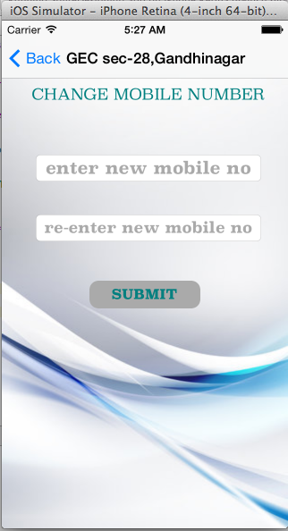

Figure 3.6: Update mobile number

* Student can select an option for change mobile number.
* In this, student enter current mobile number and new mobile number.
* After fill all fields’ students submit the form.
* **Show alert box:**

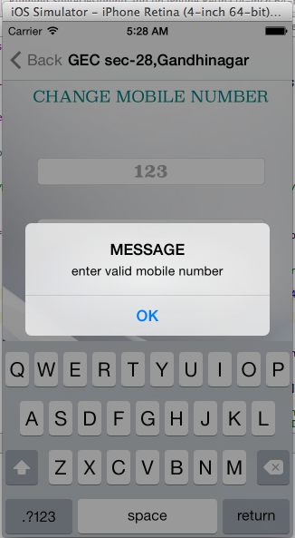

Figure 3.7: Show alert box

* After submit the form, if student enter wrong current mobile number or different new mobile numbers then an alert box is display on the screen.
* Then student re-enter the proper information.
* Same, procedure can be done in changing password and email-id.
* **Show notice Details:**

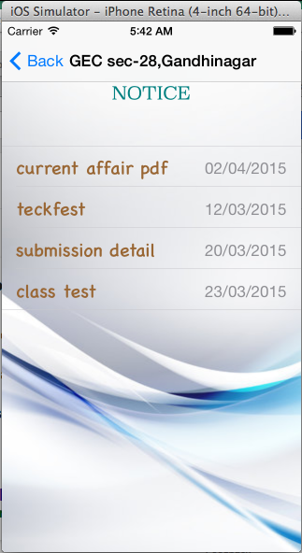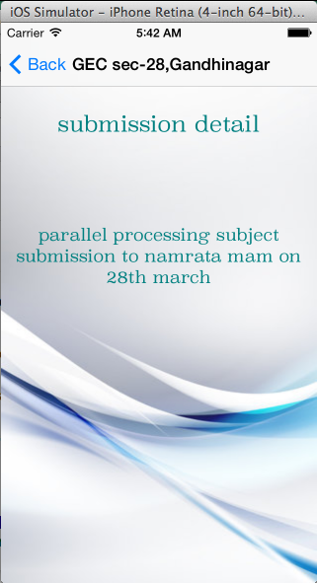 Figure 3.8: notice view

* This provides all notice information. After selecting particular notice then it shows notice description.
* **Select notes option:**

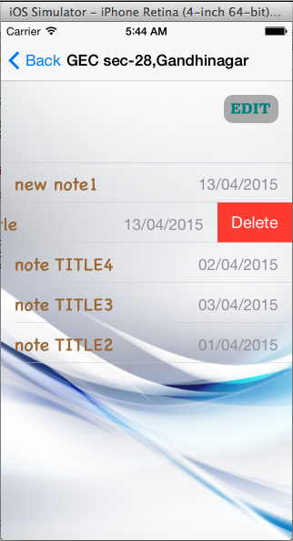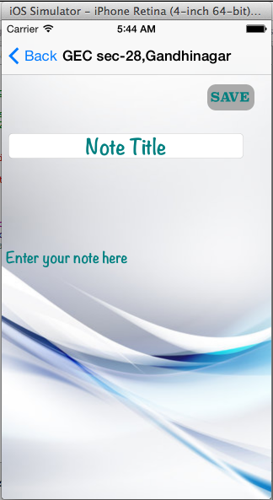

Figure 3.9: show notice

* When student select notice from option view first it shows notice title and add description of notes. After click on save button that note is saved.
* Then into second view if any student wants to change or update notes they can do this by click on edit button. If user want to delete any note then they also can do this.
* **Select placement detail option:**

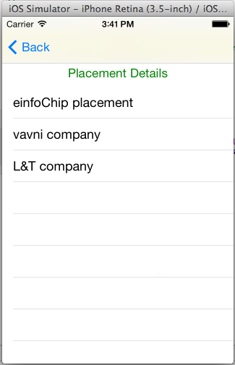

Figure 3.10 :Placement Details

* Student select placement details option.
* In this, student see new placement information list.
* From select a particular option student can see all the information regarding to selected placement.
  1. **TESTING**

“Errors are more common, more pervasive, and troublesome in software then with other Technology.”

Henceforth it is advisable to conduct proper tests and proper testing methodologies before the errors became the defects of the software.

**3.2.1 What is Software Testing?**

Software testing is the process of evaluation a software item to detect differences between given input and expected output. Also to assess the feature of A software item. Testing assesses the quality of the product.

Software testing is a process that should be done during the development process. In other words software testing is a verification and validation process.

* **Verification:**

Verification is the process to make sure the product satisfies the conditions imposed at the start of the development phase. In other words, to make sure the product behaves the way we want it to.

* **Validation:**

Validation is the process to make sure the product satisfies the specified requirements at the end of the development phase. In other words, to make sure the product is built as per customer requirements.

**3.2.2 Basics of Software Testing:**

There are two basics of software testing: blackbox testing and whitebox testing.

1. **Blackbox Testing:**

* Black box testing is a testing technique that ignores the internal mechanism of the system and focuses on the output generated against any input and execution of the system. It is also called functional testing.

1. **Whitebox Testing:**

* White box testing is a testing technique that takes into account the internal mechanism of a system. It is also called structural testing and glass box testing.
* Black box testing is often used for validation and white box testing is often used for verification.

**3.2.3 Types of Testing:**

Types of Testing are as follows:

**1. Unit Testing:**

* Unit testing is the testing of an individual unit or group of related units. It falls under the class of white box testing. It is often done by the programmer to test that the unit he/she has implemented is producing expected output against given input.

**2. Integration Testing:**

* Integration testing is testing in which a group of components are combined to produce output. Also, the interaction between software and hardware is tested in integration testing if software and hardware components have any relation. It may fall under both white box testing and black box testing.

1. **Functional Testing:**

* Functional testing is the testing to ensure that the specified functionality required in the system requirements works. It falls under the class of black box testing.

1. **System Testing:**

* System testing is the testing to ensure that by putting the software in different environments (e.g., Operating Systems) it still works. System testing is done with full system implementation and environment.
* It falls under the class of black box testing.

1. **Stress Testing:**

* Stress testing is the testing to evaluate how system behaves under unfavourable conditions. Testing is conducted at beyond limits of the specifications. It falls under the class of black box testing.

1. **Performance Testing:**

* Performance testing is the testing to assess the speed and effectiveness of the system and to make sure it is generating results within a specified time as in performance requirements. It falls under the class of black box testing.

1. **Usability Testing:**

* Usability testing is performed to the perspective of the client, to evaluate how the GUI is user-friendly? How easily can the client learn? After learning how to use, how proficiently can the client perform? How pleasing is it to use its design? This falls under the class of black box testing.

1. **Acceptance Testing:**

* Acceptance testing is often done by the customer to ensure that the delivered product meets the requirements and works as the customer expected. It falls under the class of black box testing.
* Regression Testing Regression testing is the testing after modification of a system, component, or a group of related units to ensure that the modification is working correctly and is not damaging or imposing other modules to produce unexpected results. It falls under the class of black box testing.

1. **Beta Testing:**

* Beta testing is the testing which is done by end users, a team outside development, or publicly releasing full pre-version of the product which is known as beta version. The aim of beta testing is to cover unexpected errors. It falls under the class of black box testing.

**4. CONCLUTION**

**4.1 FUTURE WORK FLOW**

This chapter indicate future activity for this project.

In whole procedure to prepare project, we first gather the requirement of the project and decide the time schedule. After planning we design the documentation of project. After the design we generate the code of system. In design the code we do the error estimation and effort estimation. If error is occur then solve it. Finally when code is designed then test the project and decide the cost of project.

|  |  |
| --- | --- |
| Duration | Activity |
| December | Learing SQLite |
| January | Connectivity with database |
| February | Application Testing |
| March | Project finishing work |
| April | Project complete |

**4.2 SCOPE OF FUTURE WORK**

This chapter describe the future scope.

**4.2.1 Features that can be added in future**

The modules that can be added in current system as a part of future extensibility are as follows:

* Placement Management System.
* Online Notice Board.
* Help and Q/A Forum.
* Hospital Management System

**4.3 CONCLUSION**

A **Smart scheduler** is an application where all the information likely to appear during student’s academic duration is managed in a well-developed manner. Working on smart scheduler application has made us realized how easy it becomes for students to manage data electronically. Doing so makes storage and information of college more reliable, remotely and rapidly accessible from anywhere.

Here with this project we would conclude that if a Smart scheduler application is built, it would be very advantageous to any college’s students, students efforts and time will be saved.

No project can be termed as ‘perfect’ in real sense and there always remains scope for further improvement which helps to develop a new update version. We are always eager to know some new points and validations related to the project which gives us more knowledge and helps us to create new version.

**4.4. BIBLIOGRAPHY AND REFERENCES**

* **Book**
* Concept in objective-c programming by apple developer.

Publish 2012 apple Inc. (83 pages).

* **Websites**
* <http://www.appcoda.com>
* <http://www.wikipedia.com>
* <http://www.techotopia.com>